**Developing Usage Metrics Report**

Usage metrics in Power BI refer to the data that tracks how users interact with Power BI reports and dashboards. It includes information like which reports are accessed, how often, by whom, and the interactions performed within those reports. These metrics help assess user engagement and the effectiveness of the content.

**Method 1**

**Create and view a new usage metrics report**

Only users with admin, member, or contributor permissions can view the usage metrics report. Viewer permissions aren't enough. If you are at least a contributor in a workspace in which your report resides, you can use the following procedure to display the usage metrics:

1. Open the workspace that contains the report for which you want to analyze the usage metrics.
2. From the workspace content list, select **More options (...)** for the report and select **View usage metrics report**.

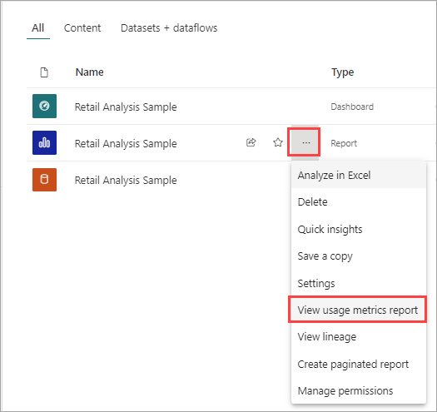

Or open the report, then on the command bar, select **More options (...)** > **Open usage metrics**.

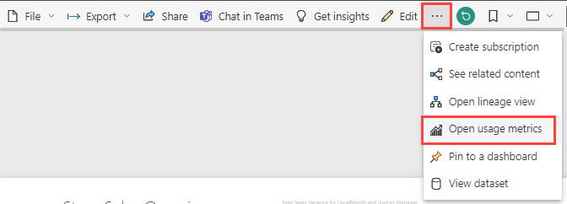

1. The first time you do this, Power BI creates the usage metrics report and lets you know when it's ready.

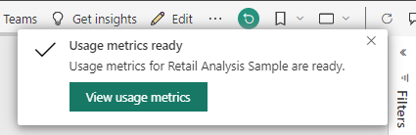

1. To see the results, select **View usage metrics**.
2. If this is the first time you've viewed a usage metrics report, Power BI might open the old usage metrics report. To display the improved usage metrics report, in the upper right corner, toggle the **New usage report** switch to **On**.

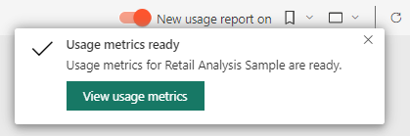

**You may need to resume scheduled refresh if one of the following occurs:**

* The credentials expire or the user who first launched the usage metrics report leaves or is no longer a part of the organization
* Removed the user who first launched or developed the usage metrics report from the workspace where the dataset resides

### Dashboard Usage Metrics report

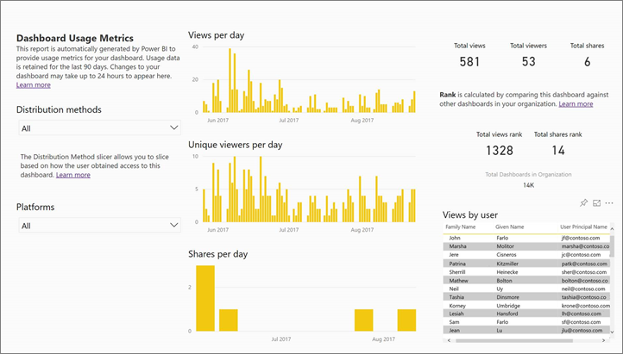

### Report Usage Metrics

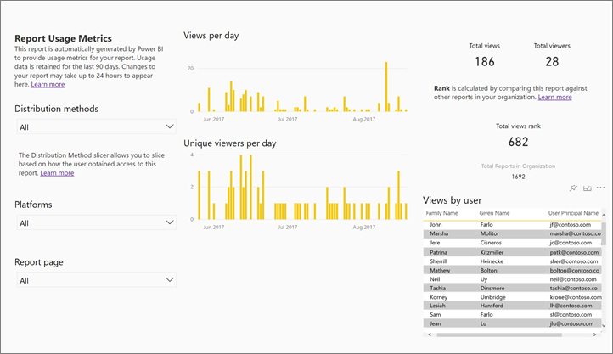

**Method 2**

**usage metrics present in Admin portal**

1. Sign in to [Power BI](https://app.powerbi.com/) by using your admin account credentials.
2. From the page header, select **...** > **Settings** > **Admin portal**.

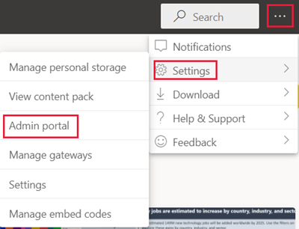

## Usage metrics dashboard

The first time you access the dashboard, or when you revisit after a long period of not viewing the dashboard, you might see a loading screen before the dashboard appears. After the dashboard loads, you see two sections of tiles. The first section, at the top of the page, includes usage data for individual users. The second section, at the bottom of the page, has similar information for groups. This section lets you see which groups in your organization are most active and what kind of content they're consuming.

The following sections of the article show a breakdown of what you can see in each tile.

### Number of users

This tile is in the first section of the report. It shows a distinct count of all dashboards, reports, and datasets in a workspace, and it refers to users. The second section of the report contains a similar tile that refers to groups.

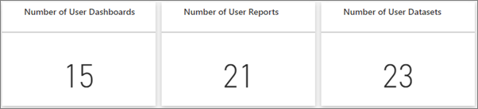

### Consumed dashboards

This tile shows a list of the most consumed dashboards. The tile in the first section refers to the number of users who consumed the dashboards. The report's second section has a similar tile that refers to the number of groups. For example, if you have a dashboard that you shared with three users and you also added it to an app that two different users connected to, the dashboard's count would be six: you, three shared users, and two app users.

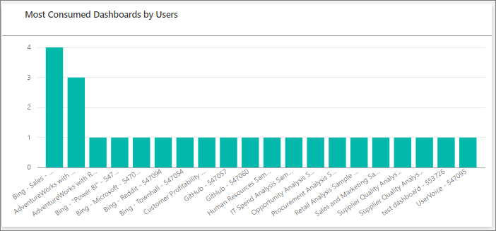

Consumed packages

This tile shows a breakdown of the most popular content. The tile in the first section shows content users connected to. The report the second section shows a tile that displays content groups connected to. The content includes anything the users could reach using the Get Data process, such as SaaS template apps, files, or databases.

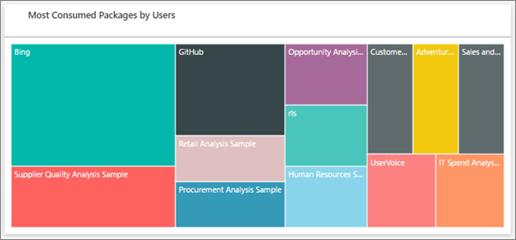

### Top users or groups based on dashboards

This tile shows a view of your top users based on how many dashboards they have. Each entry includes dashboards they created themselves and dashboards shared with them. The report in the second section shows a tile that displays top groups based on the number of dashboards they have.

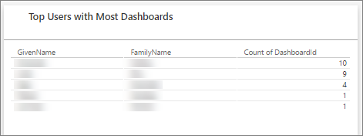

### Top users or groups based on reports

This tile shows a view of your top users based on how many reports they have. The report in the second section shows a tile that displays top groups based on the number of reports they have.

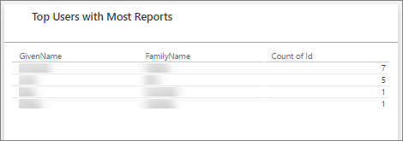

**Note:** The usage metrics present in Admin portal is different from Usage metrics for reports and dashboards. Usage metrics present in Admin portal can give overall monitoring view of which users views most of the content and which reports and dashboards have been used most. This Usage metrics will also give information related to total no. of dashboards and reports we have in our organization. Apart from this you will also able to see more information related to workspaces and other info.

**Method 3**

Creating report using  Usage Metrics Report **dataset**

You can create a usage report in Power BI Desktop, based on the Usage Metrics Report dataset. To establish a connection to the Usage Metrics Report dataset and create your own report, you have to be signed in to the Power BI service in Power BI Desktop.

1. Open Power BI Desktop.
2. If you aren't signed in to the Power BI service, on the **File** menu select **Sign in**.
3. To connect to the Usage Metrics Report dataset, on the **Home** ribbon select **Get Data** > **More**.
4. In the left pane, select **Power Platform**, then select **Power BI datasets** > **Connect**.

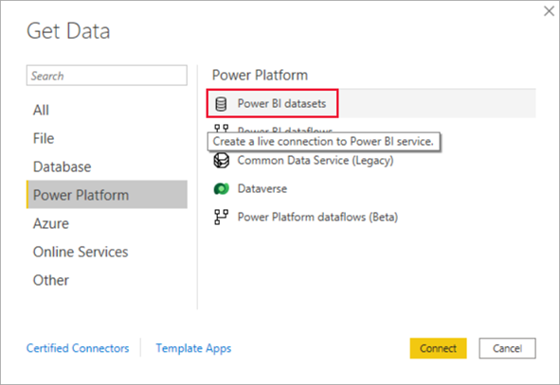

1. Scroll to the desired dataset or type Usage Metrics in the search box.
2. Verify in the Workspace column that you are selecting the correct dataset, then select **Create**.

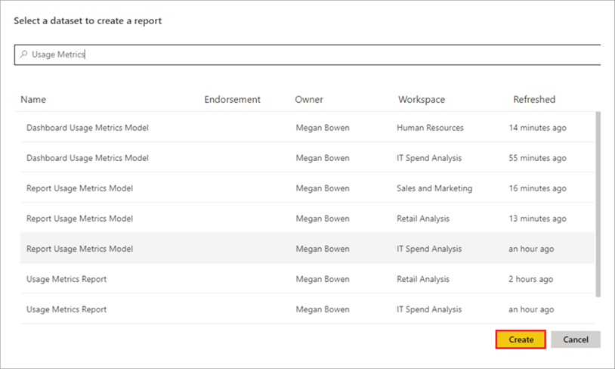

1. Check the Fields list in Power BI Desktop, which gives you access to the tables, columns, and measures in the selected dataset.

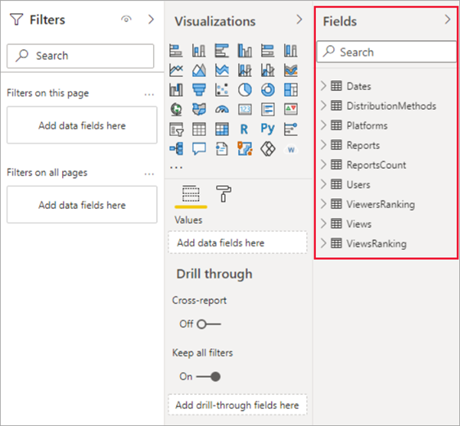

1. Now you can create and share custom usage reports, all from the same Usage Metrics Report dataset.

**Note**

When you create a usage metrics report, it's built on the original dataset. If there are any changes from Power BI, this may break your copy of the report.

## Update credentials for usage metrics report

If dataset owners in your workspace leave, are no longer a part of your organization, or if the credentials expire, the datasets may become stale and refreshes may fail. In such cases, you can use the following procedure to take over a Usage Metrics Report dataset and update the credentials.

**Note**

Updating credentials doesn't apply to My Workspace, because each user owns their own My Workspace, and they never need to transfer ownership of the dataset.

1. Open the workspace that contains the report for which you want to update the Usage Metrics Report dataset.
2. In the gray header bar at the top, select the **Settings** icon, then select **Settings**.

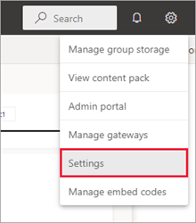

1. Switch to the **Datasets** tab.
2. Select the Usage Metrics Report dataset.

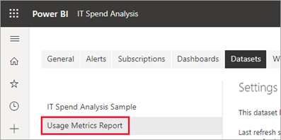

If you aren't the current dataset owner, you must take over ownership before you can update the data source credentials.

1. Select the **Take over** button, then in the **Take over dataset settings** dialog box, select **Take over** again.
2. Under **Data source credentials**, select **Edit credentials**.

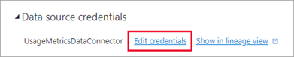

1. In the **Configure Usage Metrics Report** dialog box, select **Sign in**.

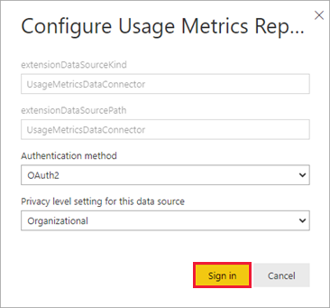

1. Complete the sign-in sequence and note the notification that the data source was updated successfully.

**Admin level changes**

## Exclude user information from usage metrics reports

Admins can limit exposure of identifying user information in the Power BI admin portal tenant settings. They can enable per-user data for the entire organization or specified security groups.

1. On the **Tenant settings** tab in the admin portal, under **Audit and usage settings**, expand **Per-user data in metrics for content creators** and select **Disabled**. This will hide user account information for all users.
2. Decide whether to **Delete all existing per-user data in current usage metrics content**. Select **Apply**.

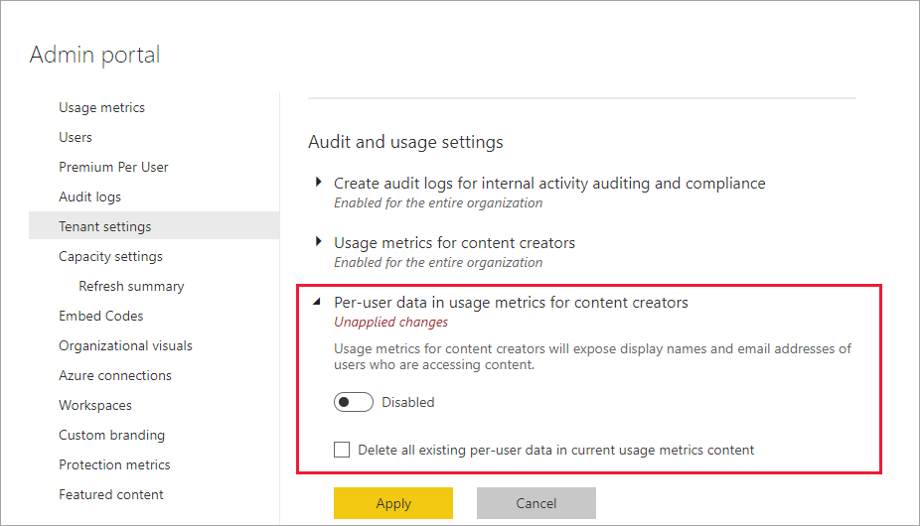

When disabling usage metrics for their entire organization, admins can use the Delete all existing usage metrics content option to delete all existing reports and dashboard tiles that were built using the usage metrics reports. This option removes all access to usage metrics data for all users in the organization who may already be using it. Deleting existing usage metrics content is irreversible.

**Note**

Only **admins** for the Power BI tenant can see the Admin portal and configure the Per-user data in usage metrics for content creators setting.

Limitation

* Usage metrics reports don't show up in Recent, Workspaces, Favorites, or other content lists and can't be added to an app
* If you pin a tile from a usage metrics report to a dashboard, you can't add that dashboard to an app.
* The Usage Metrics Report dataset contains usage data for the last 30 days. It can take up to 24 hours for new usage data to be imported. You can't trigger a manual refresh by using the Power BI user interface.
* Report Page Views rely on client telemetry and can be affected by undercounting and overcounting of activities due to network latency, ad blockers, firewalls, and network rules set by your organization, this data may never reach Power BI.
* Performance data and Report Page View metrics rely on the client/device sending data to Power BI. Depending on network latency, ad blockers, firewalls, and network rules set by your organization, this data may never reach Power BI. Therefore, the performance and Report Page View data may not include all views or all users.
* Report performance metrics aren't available for Paginated Reports.
* Initializing the Usage Metrics Report dataset might fail due to a timeout encountered during refresh. Refer to the [Troubleshooting section](https://learn.microsoft.com/en-us/power-bi/collaborate-share/service-modern-usage-metrics#troubleshoot-refresh-issues) below to resolve this or any general refresh issue.
* Page views that are made from mobile devices are not shown in the usage metrics report.
* The usage metrics report is not supported in My Workspace.
* Note that it might take up to 24 hours for new activity data to appear in the usage report.

**Above limitations delivering that usage metrics will not provide latest and exact information about usage and activities of reports**